**An Introduction to the Bible**

**Lesson 6: King David, King Solomon & then Israel splits in two!**

We remember David as the shepherd boy who killed the giant Goliath with a sling and a rock, but that isn’t the end of his story. The last of the Judges of Israel, Samuel, was told by God that God was basically “abandoning” Saul because of Saul’s behavior and that God sent Samuel out to anoint a NEW king over Israel. And all of this would happen WHILE Saul is still “official king”. A very sticky situation for whoever the next king would be. Saul would not be happy with this.

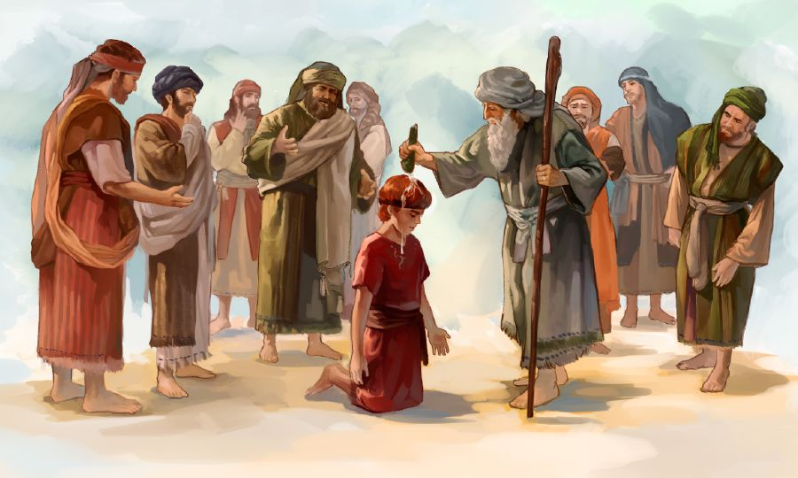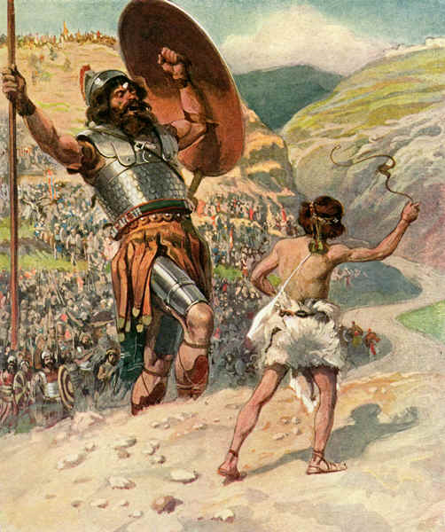

David was the youngest of a large family—all his brothers were big and strong and he was a young teenager, people think. 1 Samuel 16 has the key stories. After he’s anointed king (secretly) David continues to tend his father’s sheep and Saul is told that David is a good singer & harpist” so Saul has David come and live in the palace to sing to him. David even becomes Saul’s armor-bearer. Then Goliath shows up as the Philistine champion warrior and challenges all of Israel to have them send someone out to fight him in single combat.

***45****David said to the Philistine, “You come against me with sword and spear and javelin****, but I come against you in the name of the Lord Almighty,*** *the God of the armies of Israel, whom you have defied.****46****This day the Lord will deliver you into my hands, and I’ll strike you down and cut off your head. This very day I will give the carcasses of the Philistine army to the birds and the wild animals, and the whole world will know that there is a God in Israel.****47****All those gathered here will know that it is not by sword or spear that the Lord saves; for the battle is the Lord’s, and he will give all of you into our hands.”*

From this time on Saul got very moody and suspected the people would rather have David as a king than him so Saul tried to kill David with a spear but David dodged and fled the palace. Lots of people followed him and Saul called them “rebels” and searched for David with his own army, even while fighting the Philistines at the same time. Eventually Saul and his family (including his son Jonathan who was the best friend of David) died in battle with the Philistines.

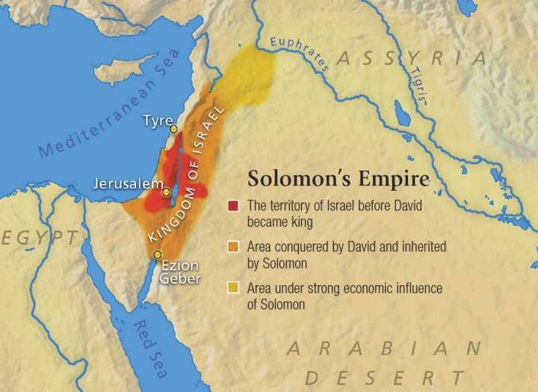

David lived and ruled around 1000 years before Jesus, or 1000 B.C. One of his gifts was being a musician and many of the Psalms in the Old Testament are connected to David—possibly written by him as prayers or hymns to be sung or read. One of David’s sins was his affair with Bathsheba and his murder of her husband and then thinking he could get away with it. God had the prophet Nathan confront David in his palace and David realized his guilt and confessed his sins. Psalm 32 and Psalm 51 are both written about this experience.

*As you read these Psalms, remember each of these were written by David after his affair with Bathsheba, his murder of Uriah, his encounter with Nathan, and his confession before The Lord. David pours himself out before The Lord, recognizing himself as a sinner, asking for God’s forgiveness, and eternal love. These Psalms serve to remind us that no matter what we have done God WANTS to forgive us for any and all of our sins.*

David’s oldest son, Absalom, should have been king but he didn’t want to wait until David’s death so he led a huge rebellion against his father and for several years their two armies battled. David never wanted his son killed but Absalom still was killed by a general of David’s after Absalom fled from a battle.

After David died of old age, his son Solomon (another son of Bathsheba) was anointed king. Solomon was supposedly one of the smartest people who ever lived. In 1 Kings 3 there’s a story of two women who share a home and each has a baby son. In the middle of the night one of the baby boys dies and his mother switches her dead baby with the other woman’s live baby so when morning comes the one mother wakes up with a dead baby in her arms and initially thinks it is hers but then realizes the other woman has her baby and is pretending it’s now hers. And she won’t give it back! She claims it’s the other woman’s baby who died in the night, not her baby who she switched with the live baby! The true mother appeals to the judge and they go before Solomon as he is known to have the ability to judge wisely. Anybody know his suggestion and why it worked?

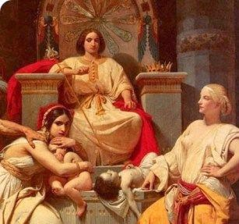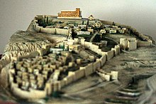

Besides being a very intelligent person, Solomon also expanded the borders of the Kingdom of Israel, built the first very special Temple in Jerusalem for the worship of God, was immensely rich and popular, had a big army, and had lots of wives. It was the time in history when Israel was a regional power (not as big and powerful as Assyria or Babylon or Persia though.) Back in that time, rulers (almost all were male, although the Queen of Sheba ruled over some of the area of Egypt at the same time Solomon ruled. She even traveled to Jerusalem to meet Solomon!) There is even a theory that somehow the real Ark of the Covenant went back to her country and may still be there somewhere. Raiders of the Lost Ark, anyone?

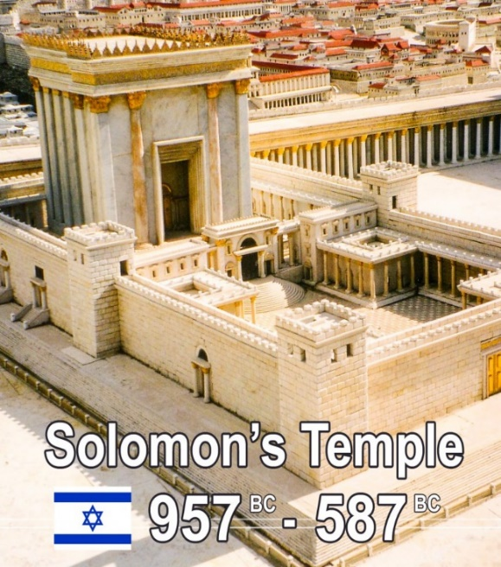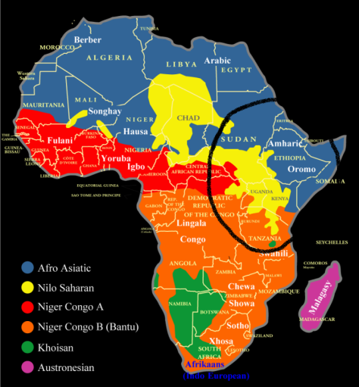

And after Solomon died, guess what? Everything fell apart. The entire nation of Israel considered who was now their new king—Solomon’s son Rehoboam—and ten of the twelve tribes voted NOPE and rebelled and said that they would find their own king and worship at their own site (and not pay taxes to Rehoboam either, by the way.) So now what had been a single nation was now two!

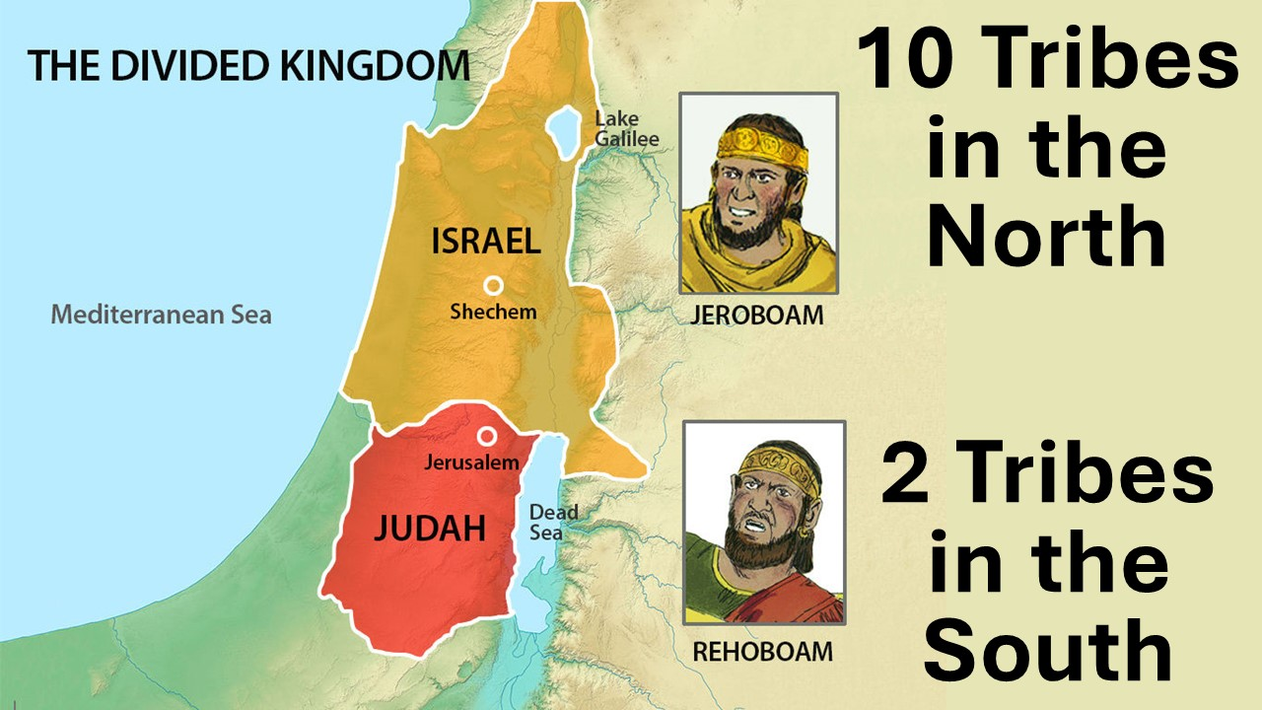

1 and 2 Kings along with 1 and 2 Chronicles are all about the kings and the struggles of both Israel and Judah. In 2 Chronicles 25 they fight each other, and Israel defeats Judah. In 2 Kings 17 the entire nation of Israel is conquered by the armies of Assyria and its’ people are taken as slaves or driven out; all of these people are called the “Ten Lost Tribes of Israel”. In 2 Kings 25 and 2 Chronicles 36 we have a summary of Judah’s defeat and captivity by the armies of Babylon!