**An Introduction to the Bible**

**Lesson 5: Joshua leads after Moses’ death plus the Judges!**

What was the handover from Moses to Joshua?

## *So the LORD said to Moses, “Take Joshua son of Nun, because my Spirit is in him. Put your hand on him, and have him stand before Eleazar the priest and all the people. Then give him his orders as they watch. Let him share your honor so that all the Israelites will obey him.* **Numbers 27:18-21**

**Death of Moses**

**4**Then Moses climbed Mount Nebo from the plains of Moab to the top of Pisgah, across from Jericho. There the Lord showed him the whole land—from Gilead to Dan, **2**all of Naphtali, the territory of Ephraim and Manasseh, all the land of Judah as far as the Mediterranean Sea, **3**the Negev and the whole region from the Valley of Jericho, the City of Palms, as far as Zoar. **4**Then the Lord said to him, “This is the land I promised on oath to Abraham, Isaac and Jacob when I said, ‘I will give it to your descendants.’ I have let you see it with your eyes, but you will not cross over into it.”

**5**And Moses the servant of the Lord died there in Moab, as the Lord had said. **6**He buried him[[a](https://www.biblegateway.com/passage/?search=Deuteronomy%2034%3A1-8&version=NIV#fen-NIV-5846a)] in Moab, in the valley opposite Beth Peor, but to this day no one knows where his grave is.

One battle recorded in Joshua is the battle of Jericho. This introduces a woman named “Rahab” to us. Like many people in huge walled cities (with walls about 30 feet thick!” she and her family lived inside the walls and had a window that opened to the outside. She met two Hebrew spies and decided to hide them from the local police who were searching for them. In return she got the Hebrew spies to promise to spare her and her family when Jericho fell (as she knew it would).

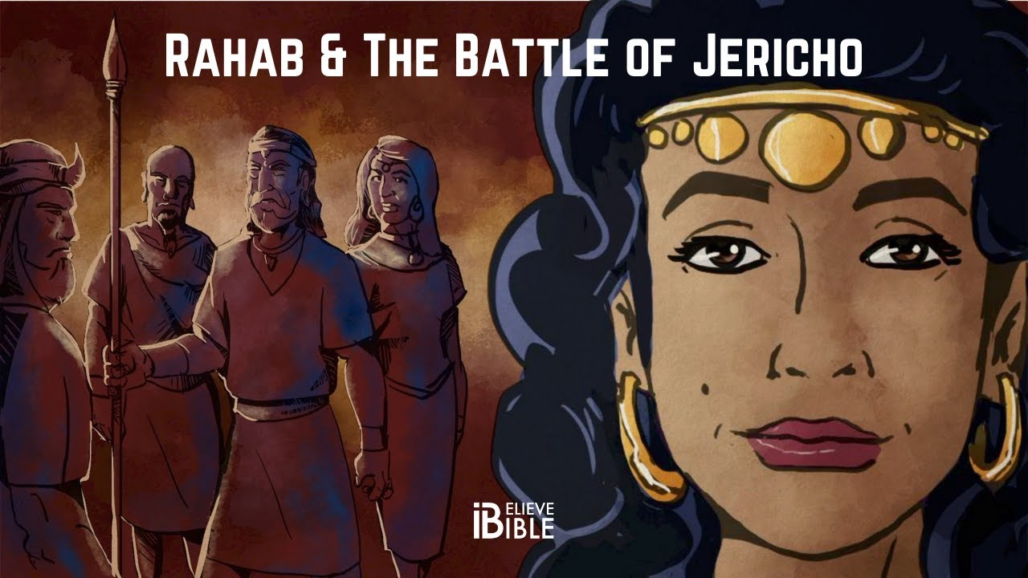

Joshua 2:10 &11 has her confession of her faith in God to the spies: ***10****We have heard how the Lord dried up the water of the Red Sea[*[*a*](https://www.biblegateway.com/passage/?search=Joshua+2%3A10-11&version=NIV#fen-NIV-5880a)*] for you when you came out of Egypt, and what you did to Sihon and Og, the two kings of the Amorites east of the Jordan, whom you completely destroyed.[*[*b*](https://www.biblegateway.com/passage/?search=Joshua+2%3A10-11&version=NIV#fen-NIV-5880b)*]****11****When we heard of it, our hearts melted in fear and everyone’s courage failed because of you****, for the Lord your God is God*** *in heaven above and on the earth below.*

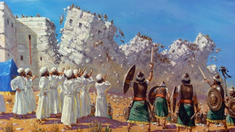

Why is Rahab mentioned? She’s mentioned in the New Testament in the “Faith Chapter” of Hebrews 11 in verse 31. And her key mention is in Matthew 1:1-6 where it turns out she ends up marrying a Hebrew named “Salma” and they have a son named “Boaz” (of the story of Ruth and Boaz!), and Boaz and Ruth have a son named “Obed” and he has a son named “Jesse”, and he has a son who is a shepherd boy named “David” who becomes King of Israel and is an ancestor of Jesus! So Rahab of Jericho was the great-grandmother (?) of King David!

After the Hebrews conquer the Promised Land and drive “most” of the people who had lived there out the question then becomes to them, “How are we going to continue to be led by God? Nations around us have kings and we have priests!” So God instituted a group that was part governor, part judge, and part prophet/priest and called them “Judges”. One at a time served the entire nation of Israel. Almost all were men but one was a woman!

*The Book of Judges mentions twelve leaders who are said to "judge" Israel: Othniel, Ehud, Shamgar, Deborah, Gideon, Tola, Jair, Jephthah, Ibzan, Elon, Abdon, and Samson.*

Judges 4 has a story of Deborah judging Israel and how they fought against King Sisera. They defeated his army but he fled on foot and a woman named “Jael” told him to come into her tent and rest and when he fell asleep she killed him.

Another famous judge that movies have been made about is SAMSON, who was an immensely strong man with only one weakness—he could never get his hair cut or he would lose his strength. At this time the Israelites were fighting the Philistines and Samson fell in love with a bad woman—Delilah. She was one of the enemy and kept trying to figure out how Samson was so strong and how she could take away his strength. Judges 14-16 tell his story and of how Delilah had his hair cut off when he slept so Samson could be captured, chained, and put on display by the Philistines. Unfortunately for them, his hair had begun to grow back, so he prayed to God for one final time of strength, and even though he was chained he pushed down two pillars that held up the roof of the building where a bunch of Philistines were eating and he killed them all, including himself, when the roof collapsed on everyone.

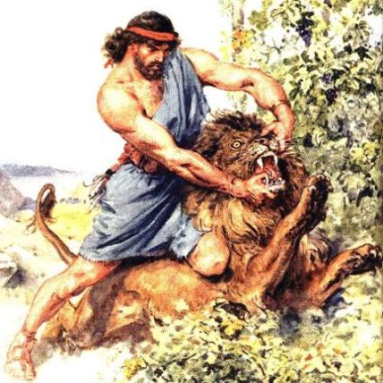 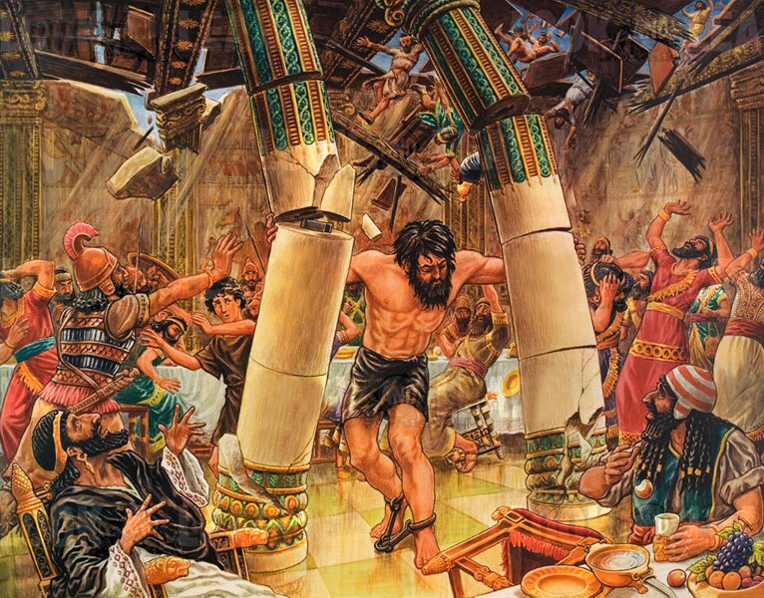

A key sentence in the book of Judges is the very last verse in the book—the judges did their best to keep order and fight enemies and keep people from falling away from God but it was just too many hats to wear. There were some good judges (Eli and Samuel were the last two of them) but the Hebrew people had seen all the other nations around them have kings and they thought that maybe it was time for them to have a king, too, so they could be just like everyone else. In 1 Samuel 10:17-27 we have the story of how they chose their first king—by casting lots to narrow down who God would pick.

First they chose which tribe the king would be from—12 choices to pick from, and the tribe of Benjamin was chosen. Then that tribe was divided up again into family groups, then specific families, and finally by each man. And Saul was chosen. He “LOOKED” like a king but didn’t have the character necessary to do this.

Saul was chosen to lead the Israelites against their enemies, but when faced with Goliath he refuses to do so; Saul is a head taller than anyone else in all Israel (1 Samuel 9:2), which implies he was over 6 feet (1.8 m) tall and the obvious challenger for Goliath, yet David is the one who eventually defeated him.

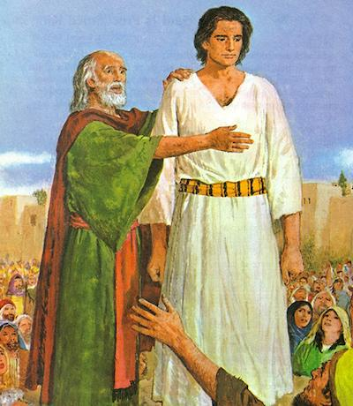

**Saul was popular and was kind of like a “Homecoming King” whom people like, but couldn’t make the tough decisions needed. After Samuel dies Saul goes to a medium and has her bring up Samuel’s spirit from the dead (which is forbidden!) Saul also has massive mood swings and tries to kill David.**

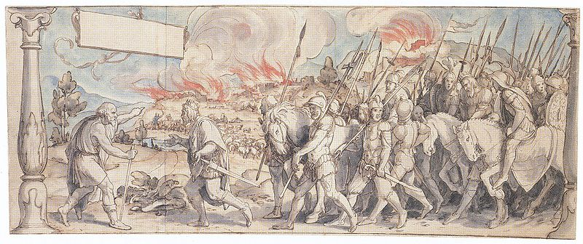

Eventually, Saul dies in battle with the Philistines and David becomes King.