**An Introduction to the Bible**

**Lesson 3-- takes Israel into Egypt; Moses gets them out**

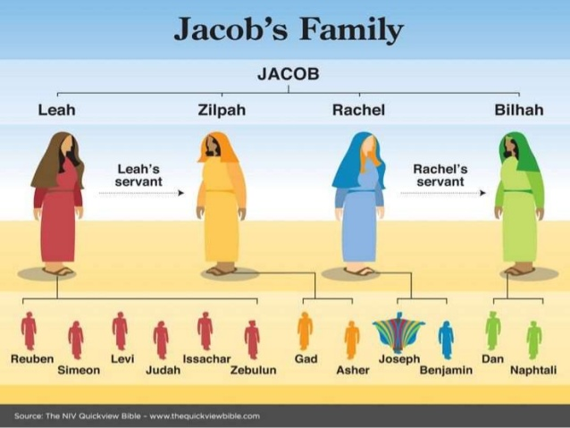

Jacob had daughters also, but in a patriarchal society, sons were the “currency” that were more valued. Leah (Rachel’s older sister) had six sons, including the oldest of them all—Reuben. Rachel only had two sons (Joseph and Benjamin) before dying. Leah’s maid Zilpah had two sons, as did Rachel’s maid Bilhah.

These men became the founders of “**The Twelve Tribes of Israel**.” How does that happen when Jacob is their father? *Genesis 32-33 tells of Jacob and Esau's eventual meeting according to God's commandment in Genesis 31:3 and 32:10 after Jacob had spent more than 20 years staying with Laban in Padan-Aram.*

Here's the story of how Jacob got his named changed by the angel of the Lord (God) to a NEW name: Israel!

Even after 20 years Jacob still isn’t sure how his older twin Esau feels about him and whether or not Esau has forgiven him, so when he finally returns home with all of his family, livestock, and riches. He sends everyone and everything across the Jabbok river first and spends his last night alone—until an angel comes at night and wrestles with him. Neither can win the fight—and when dawn is finally near the angel needs to leave and Jacob won’t let him go, so two things happen: the angel puts Jacob’s hip out of joint and gives him a new name: Israel. In Hebrew, this new name basically means, “You have striven with God and have prevailed.”

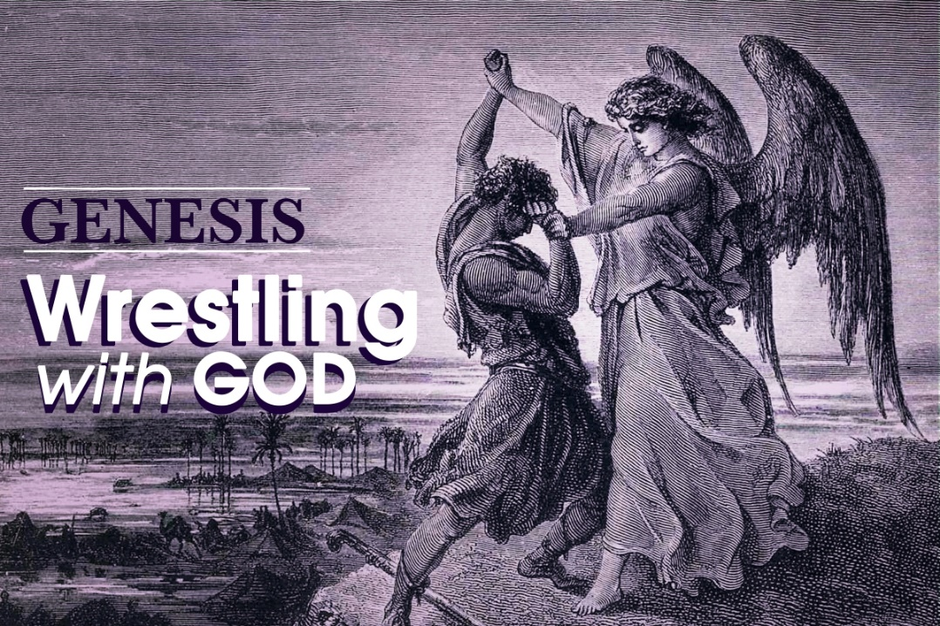

Meanwhile, what’s happening in Egypt with Joseph—Jacob’s youngest son (so far)? Jacob gave him a fancy many-colored cloak and he wore it out to the field to visit his brothers (first mistake). Then he told his brothers about a couple dreams he had that were interpreted by them as Joseph eventually lording it over them (second mistake.) So they were going to kill him but the oldest brother (Reuben) talked them out of doing that and selling him into slavery instead.

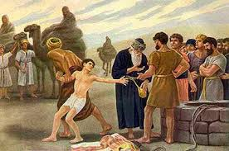

They took Joseph’s fancy cloak (anybody heard of “Joseph and the Amazing Technicolor-Colored Dreamcoat”?) and smeared it with blood and told their father Jacob that an animal had killed Joseph and taken his body away. So Jacob is very sad with this news and thinks Joseph is dead while he ends up in Egypt as a slave.

What makes the difference for Joseph is that God still helps him interpret dreams—his own AND dreams other people have who tell him about them. This gift eventually gets him out of prison and brought to Pharaoh’s attention!

*There Joseph eventually gains the favour of the pharaoh of Egypt by his interpretation of a dream and obtains a high place in the pharaoh's kingdom. His acquisition of grain supplies enables Egypt to withstand a famine. Driven by the same famine, his brothers journey from Canaan to Egypt to obtain food.*

In Genesis 41, Pharaoh has a recurring dream about fat cows and skinny cows and doesn’t know what it means so he asks all the members of his court who can interpret this dream. One of them remembers Joseph, who interpreted HIS dream when he was in prison with him. Pharaoh sends for Joseph who hears the dream and tells Pharaoh the bad news about a famine on the way, but now they have time to prepare and are the ONLY nation to stockpile grain to sell to those who need it. And guess who show up to buy grain? And Joseph recognizes all of his brothers but they fail to recognize him. So it COULD be “payback time”, right? But all Josph wants to do is see his little brother Benjamin and have him brought to him.

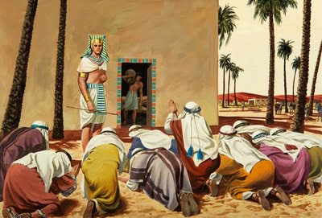

So eventually, Jacob reveals himself to his brothers and they are shocked and stunned and scared to learn that Joseph has all this authority under Pharaoh and is second in power only to Pharaoh. Will he want payback? Joseph only wants to see his father again (his mother had died in childbirth giving birth to Benjamin, his only full brother in the family) and his little brother.

Since the famine is still going on all over the middle east and Egypt is the only nation that has plenty of grain, Joseph tells his brothers to move all of their families and livestock down to Egypt and live there since he can take care of them. His brothers are still very scared that Joseph will take some kind of revenge on them once their father Jacob dies, but Joseph promises that this won’t happen.

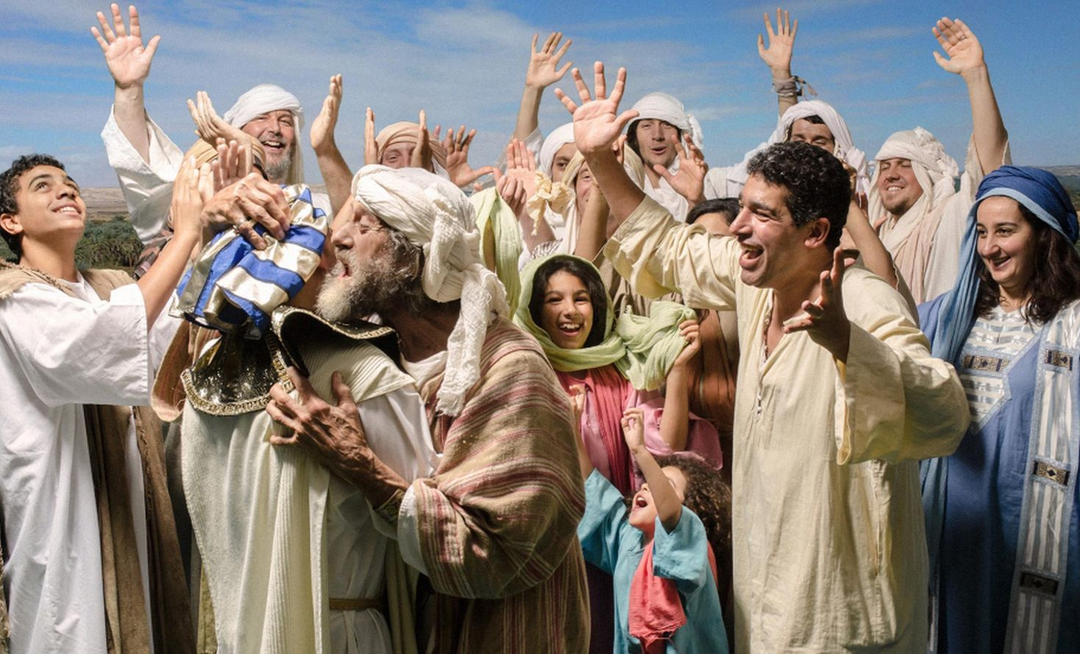

***45****Then Joseph could no longer control himself before all those who stood by him, and he cried out, “Send everyone away from me.” So no one stayed with him when Joseph made himself known to his brothers.****2****And he wept so loudly that the Egyptians heard it, and the household of Pharaoh heard it.****3****Joseph said to his brothers, “I am Joseph. Is my father still alive?” But his brothers could not answer him, so dismayed were they at his presence.*

***4****Then Joseph said to his brothers, “Come closer to me.” And they came closer. He said, “I am your brother, Joseph, whom you sold into Egypt.****5****And now do not be distressed or angry with yourselves because you sold me here, for God sent me before you to preserve life.****6****For the famine has been in the land these two years, and there are five more years in which there will be neither plowing nor harvest.****7****God sent me before you to preserve for you a remnant on earth and to keep alive for you many survivors.****8****So it was not you who sent me here but God; he has made me a father to Pharaoh and lord of all his house and ruler over all the land of Egypt.*