An Introduction to

**The Bible**

We begin with an understanding of how we mark TIME!

We divide all of our years and centuries by the life, death and resurrection of Jesus Christ! The years before Jesus are termed “B.C.”, which means “before Christ” or “Before the Common Era” and WAY BACK in Abraham’s day in Genesis, he lived around 1,800 years before Christ, so he lived in 1800 B.C. Here’s where it gets interesting: Abraham’s son, Isaac, lived around 1750 B.C. and his son Jacob lived around 1700 B.C. and his son Joseph lived around 1650 B.C. Anybody know how this can be? Today, if you were born in 2010 you now live in 2023. What gives? How come the years get less/smaller as we mark them up until Jesus’life?

**Discussion Questions for your Group:**

Q: What do you think the word “Bible” mean?

Q: If someone asked you, “What is the Bible?”, how would you answer them?

Q: Why do we have the Bible? (Two Bible passages from the Gospel of John to look up and perhaps say out loud together: John 3:16-17 and John 20:30-31)

Have students look in the front of their Bibles to see the names of different books of the Bible and the pages where they start. Is there a summary in your Bible of what the book is about AND/OR when they estimate the book might have been written down?

The stories in Genesis chapters 1 through 11 were repeated for centuries before they were ever written down! In Genesis 1-11 this is what one person wrote:

*Genesis is divided into two main parts. Chapters 1-11 detail the story of God and his relationship to the whole word, while chapters 12-50 focus on the story of God's relationship with Abraham and his family.*

There are LOTS of questions we have about Genesis 1-11….BUT sometimes the answers aren’t as clear as we would like.

**When you need to write something that will let everyone else in your class know exactly what they need to know (for instance, to attend a school dance), what are the questions people will have about this event you need to answer?**

WHO

WHAT

WHEN

WHERE

HOW

WHY

**How often does the Bible answer some of these questions? If you ask the Bible to answer ALL of these questions ALL of the time in EVERY chapter of EVERY book you will become frustrated as many of the stories (especially in the Old Testament!) aren’t written that way! (Especially Genesis 1-11). Why not? Well, here’s how we understand the universe NOW.**

. 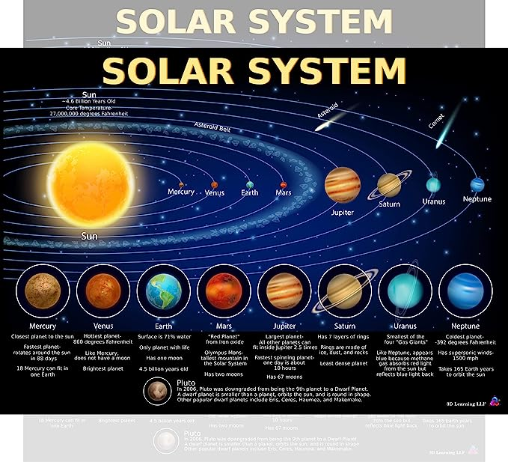

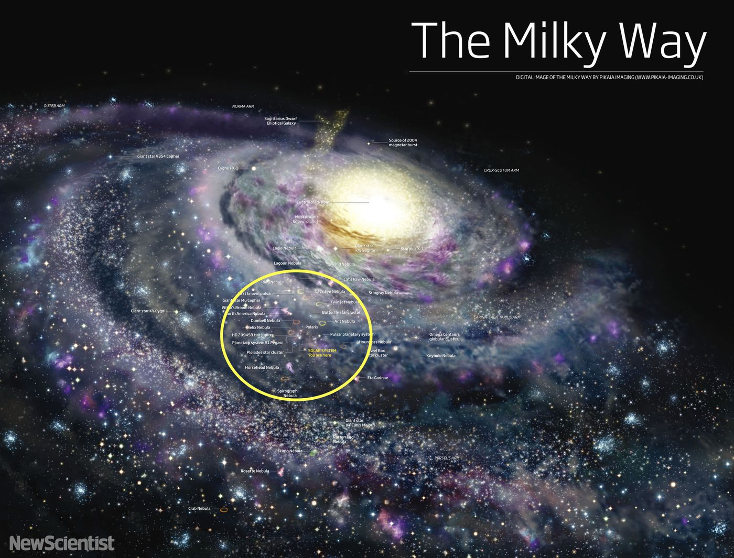

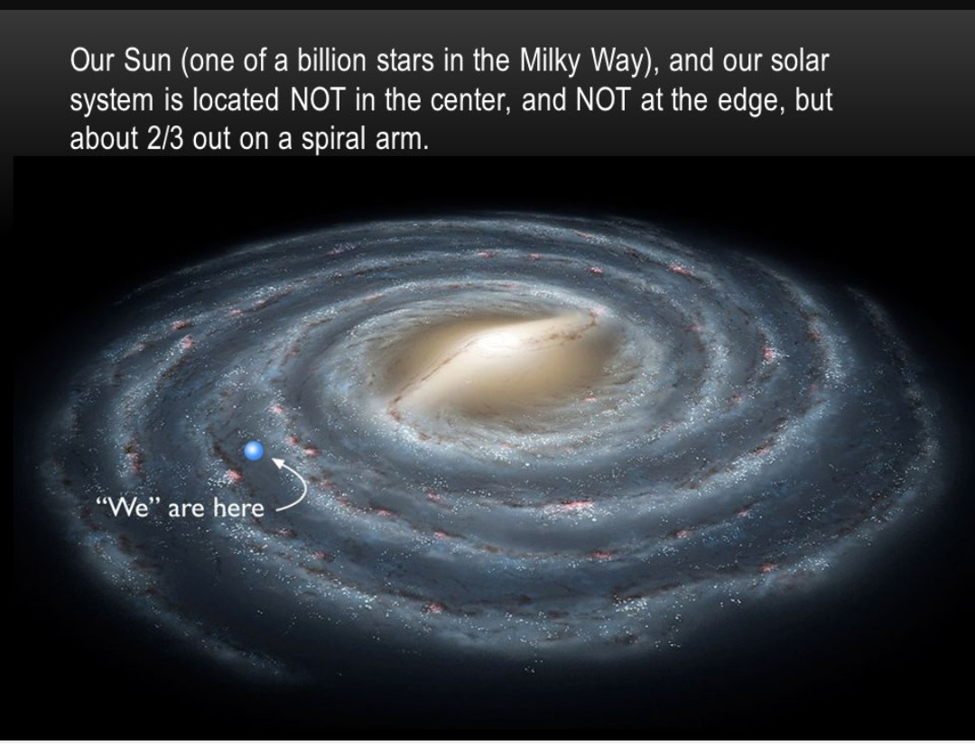

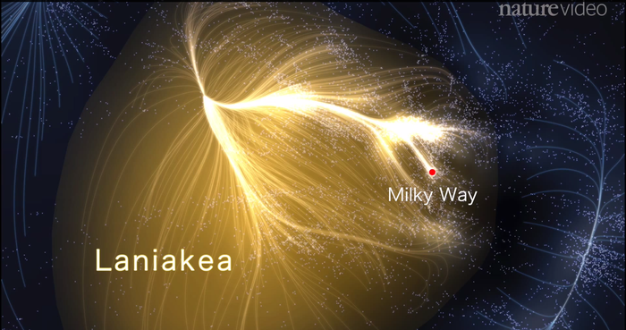

*“Laniakea” means immense heavens, open skies or wide horizons in Hawaiian.*

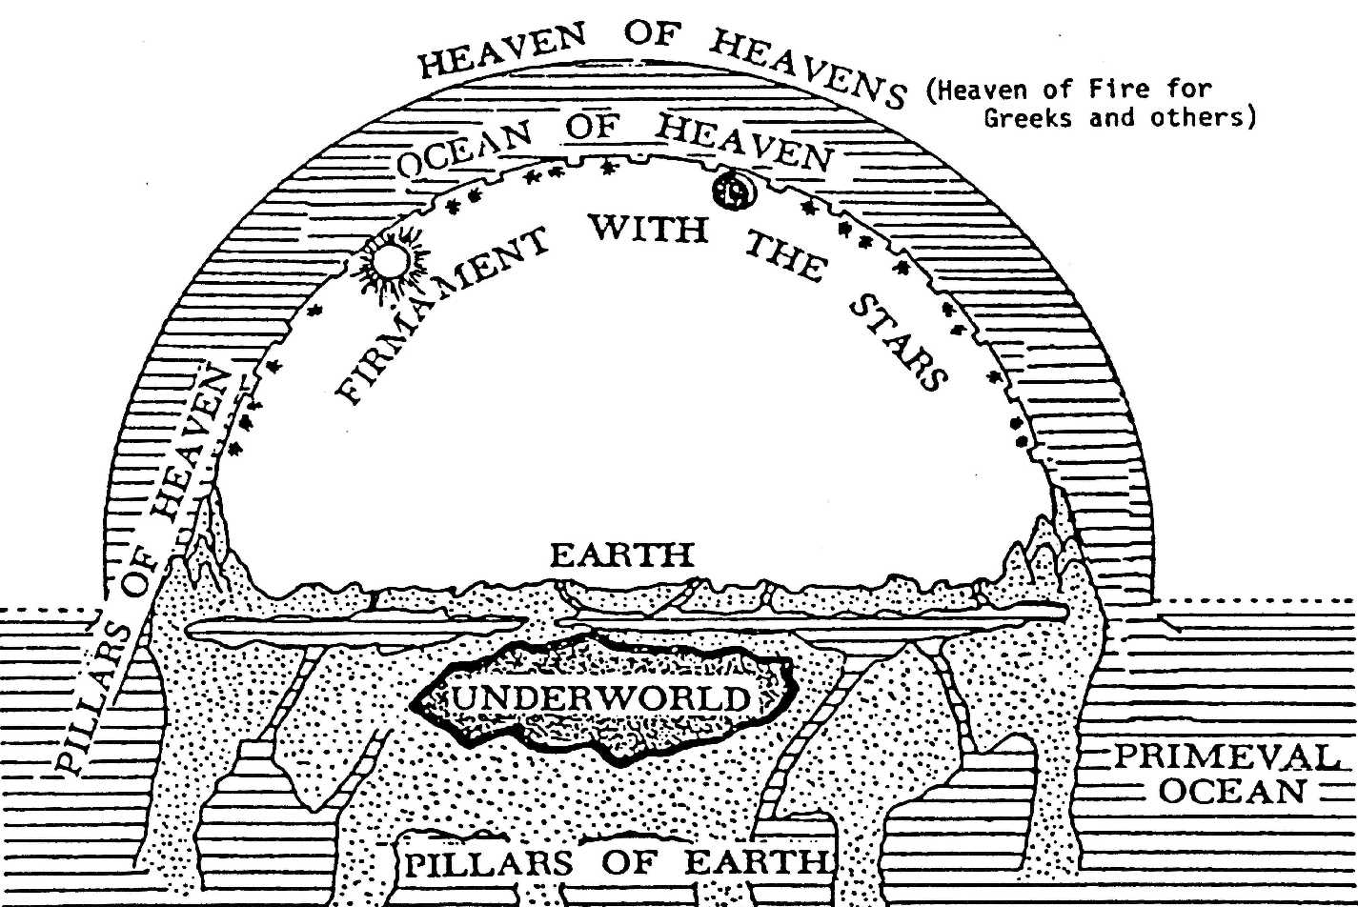

This is how people in both the Old Testament (the world before Jesus) and in the New Testament (the world after Jesus) understood the universe!

Remember the diagram about how people of that era understood the world? What if, in the story of Methuselah (Genesis 5:21-27) who was the grandfather of Noah and who lived 969 years(!!!) the people of that time counted “years” differently than we do? One theory says that ancient people didn’t keep track of the earth’s journey around the sun but instead measured time according to the cycles of the moon, so every 30 days or so you’d have a new moon cycle! If you divide 969 by 12 (as in 12 months/year) you have 80.75 “years” which might make more sense as the life span of people in ancient times was really short! People in ancient times lived around 30-40 years on average.

Another illustration: the Great Flood mentioned in the Bible has Noah and his family surviving. According to history and geology, there have been several huge regional floods centuries ago. Here’s an article and a map of one “flood” that impacted a huge area. Compare this map with one in the back of your Bible.

*In late 1997, oceanographers William Ryan and Walter Pitman of the Lamont-Doherty Earth Observatory in Palisades, New York, published evidence from sediment cores that about 5500 B.C., water from a rising Mediterranean began spilling over into the nearby Black Sea, raising water levels 15 centimeters a day; by the time the flood was over, the sea had risen about 150 meters (*Science*, 20 February 1998,*[*p. 1132*](http://www.sciencemag.org/cgi/content/summary/279/5354/1132?adobe_mc=MCORGID%3D242B6472541199F70A4C98A6%2540AdobeOrg%7CTS%3D1691079418)*).*

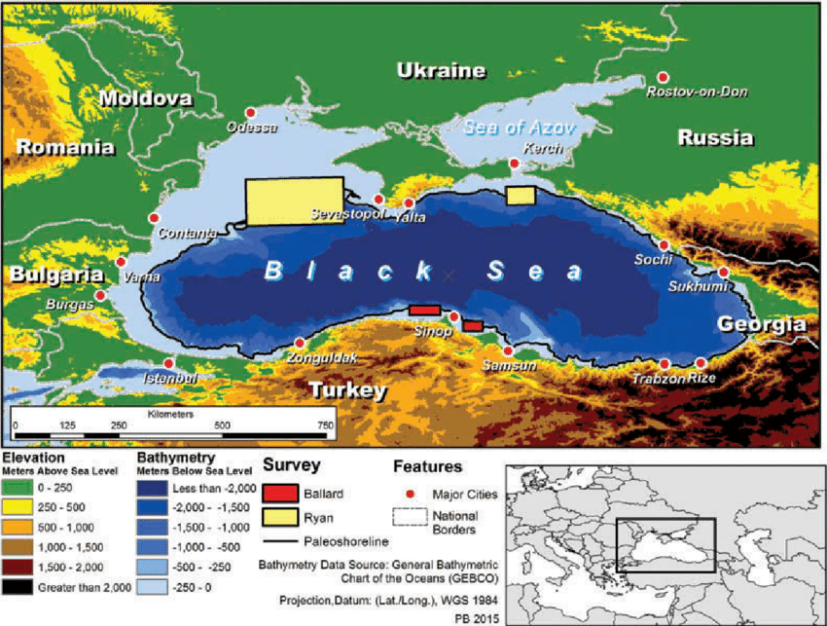

Perhaps 150 meters doesn’t seem like a lot, but it’s almost two football fields in height (not length). So the water spread out a lot and only the land above that depth stayed dry and not flooded. (In this illustration, the waters do NOT recede like they do in the Noah story!) The map shows the Ukraine and Russia, too!

**FINAL THOUGHTS BEFORE DISCUSSION AT YOUR TABLE**

Genesis 1 and 2 and 3 deal with how creation happened, according to the understanding of the people who lived then. But are the “7 days of creation” measured the same way we measure “days”? Look up 2 Peter 3:8 and Psalm 90:4 to see if that helps answer the questions “how?” and “when?”

*Question 1: What is the ELCA official position concerning the origin of life and evolution? The ELCA has not officially taken a position about evolution. The ELCA teaches that the scriptures witness that all of life is a gift of God. However, the scriptures do not say, for example, how God's creating word, "Let there be...," brings creatures into being. Lutheran tradition has respected the work of the natural sciences in investigating phenomena in the natural world and explaining how they work and how they originated. Because our knowledge both of God and of other things is partial (I Corinthians 13:9), what is accepted at any one time as valid scientific knowledge and theory can be either added to or corrected by further scientific investigation and better theories to explain the phenomena we see in the world.*

(Pope Francis has a Masters degree in Chemistry from the University of Buenos Aires. Here’s a quote from him*: He repeated the idea of God not being a “magician,” an entity that conjured all into being. “God is not... a magician, but the Creator who brought everything to life,” Francis said. “Evolution in nature is not inconsistent with the notion of creation, because evolution requires the creation of beings that evolve.”Oct 28, 2014*

**FINAL THOUGHTS:**

We want ALL of our questions about the Bible answered, but when it comes to creation, how evil got into the world, the flood story, the tower of Babel, sometimes we have to accept that not all our questions fit for the moment into God’s framework…..but we will know all the truths in the next life!