**An Introduction to the Bible**

**Lesson 7: Babylonian exile & prophets Isaiah, Jeremiah, Ezekiel**

**2 Kings 24:1-9**The following year (605BC), King Nebuchadnezzar of **Babylon**invades **Judah**and King Jehoiakim is forced to become a vassal king (see **8** on [**Map 60**](http://www.thebiblejourney.org/biblejourney2/33-judah-after-the-fall-of-israel/assyrians-settle-in-samaria/)).

After three years (in 602BC), Pharaoh Neco of **Egypt** re-takes **Gaza** from the Babylonians (see Jeremiah 47:1), and Jehoiakim rebels against his overlord, Nebuchadnezzar. In December 599BC, Babylonian, Aramean, Moabite and Ammonite forces are deployed against **Judah**. Jehoiakim is killed and is succeeded by his son Jehoiachin in 598BC.

**2 Kings 24:10-20**Later in 598BC, Nebuchadnezzar beseiges **Jerusalem.**King Jehoiachin surrenders in March 597BC and ten thousand Judaeans (including the prophet Ezekiel) are taken captive o **Babylonia**). Nebuchadnezzar strips the Temple of all the gold articles made by King Solomon. Jehoiachin is taken to **Babylon** and Zedekiah is installed in his place as a puppet king for eleven years (597-587BC). Eight years later, in 589BC, Zedekiah rebelled against Nebuchadnezzar and **Jerusalem** was besieged again. For several months, the new king of **Egypt**, Pharoah Hophra, came to the aid of **Israel**(see Jeremiah 37:6-8 & 44:30); but after a seige lasting for over a year and a half, **Jerusalem** finally fell in 587BC. The Temple was destroyed and the population was taken into exile in **Babylonia**(see 2 Kings 25:1-10).

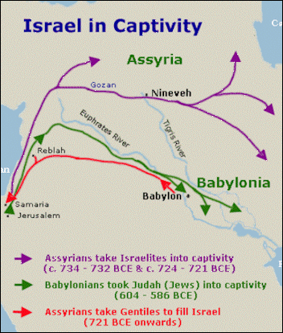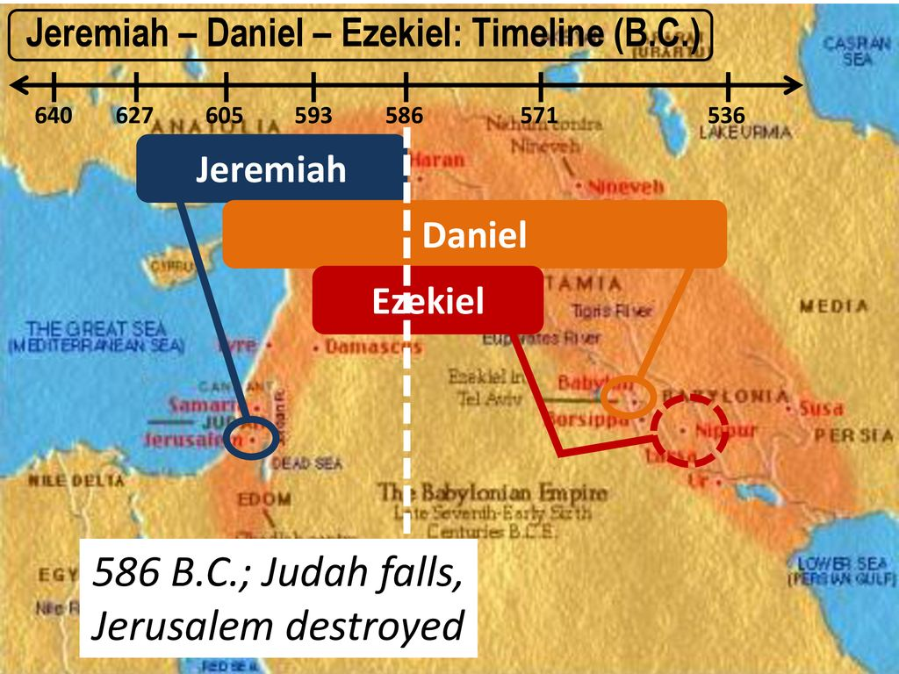

The kings of Judah kept making wrong decisions and thought they could make treaties with Egypt to protect them. The armies of Egypt actually kept their word at times but in the end they didn’t want to sacrifice their soldiers for a little nation like Judah. Around 586 the armies of Babylon broke thru the walls of Jerusalem and destroyed the Temple Solomon had built 400 years earlier. Then much of the gold and lots of the stuff in the Temple was taken to Babylon with the exiles. The walls of the city were torn down; the Temple was torn down; the crop land was salted so it wouldn’t grow crops for years. This was their situation. The Hebrews had to figure out how to worship God in a strange land without any Temple; they didn’t know if they would be slaves in Babylon; they didn’t know if they’d ever be able to come back to this land God had promised to Abraham.

*Isaiah is one of the most well-known prophets in the Bible for his prediction of the coming of the Messiah, who would redeem His people from their sins. A book of stark contrasts, Isaiah juxtaposes terrifying warnings of judgement and destruction with uplifting promises of hope and prosperity.*

**Page 734 of your Bible has listed some of the great Bible verses of Isaiah.**

Chapters 1-39 include times when Isaiah goes to the different kings of Judah and both warns them of what is about to happen (Babylon will conquer them!) and at the same time talk about HOPE in the distant future when God will send a Messiah (Jesus) to them who will be a savior of the world. Chapters 40-66 speak of God letting the people return to Jerusalem and how God will be with them and how they are to rebuild the city and temple.

**M-8 and M-9 have maps of the places that conquered Israel and Judah**

These three people—Isaiah, Jeremiah, and Ezekiel—are considered to be the “Major Prophets” of the Old Testament. The others (listed in the front of your Bible on page iii) starting with Hosea and continuing with Malachi are considered to be “Minor Prophets” of the Old Testament. The book of Daniel is kind of on its’ own as some consider it a prophetic book and others consider it part of the “Writings” section. By the way, the Old Testament has generally been divided into 3 sections: The LAW (first 5 books), the PROPHETS (what we are studying) and the WRITINGS (Psalms, Proverbs, etc.)

*Prophets receive direction from God to help people navigate challenges and situations. In the Bible, prophets urged the people to repent and foretold of the birth, death, and Resurrection of Jesus Christ. Today, prophets continue to testify of Jesus. They also warn and advise all people about important topics.*

**Isaiah** is unique because his book covers 3 sections of history! The first 39 chapters of this book cover life in Jerusalem and his prophesying to the people about Babylon and how that nation will conquer them. Then chapters 40-55 cover the time IN exile in Babylon where Isaiah prophesies about how God is about to let them return and how God will free them! The final section of Isaiah is preached to the people of Israel now back home and God’s plan for them and for the entire world in the future!

**Jeremiah** covers the period just before Babylon conquers Jerusalem and how he keeps trying to get the people to repent and do better, but where Jeremiah basically says God is not going to step in and save them from being conquered here and this is going to happen now matter what they do.

**Ezekiel** is written while the exiles are in Babylon but some of it could be a vision of Ezekiel remembering the time right before the conquest. He also prophesies about God’s vision of the future and how they will redivide the land once they return and how they will rebuild the Temple of Solomon.

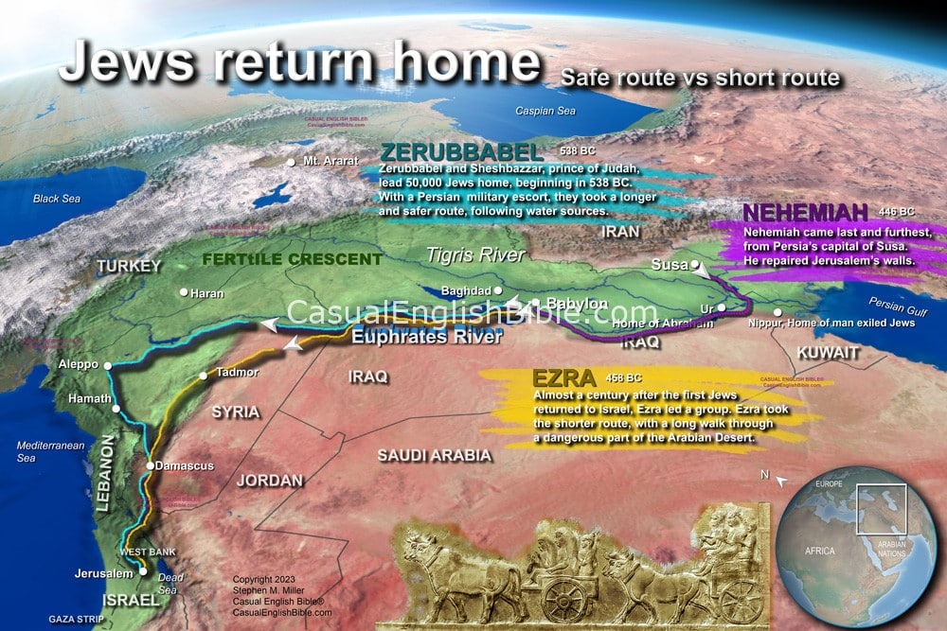

The books of **EZRA** and **NEHEMIAH** deal with the exiles who have returned to Jerusalem from Babylon. They find people living where they used to live and these people are ALSO Jews who weren’t taken captive but were left behind by the Babylonian army because they basically weren’t significant. These folks left behind have intermarried with the other non-Jewish locals and don’t exactly welcome back the returning exiles. They are now expected to share their land and food AND help these newcomers rebuild the Temple AND the walls of Jerusalem, which have both been torn down for 70 years or so. Ezra and Nehemiah talk about the struggles of the people of Israel to rebuild and keep order and peace.

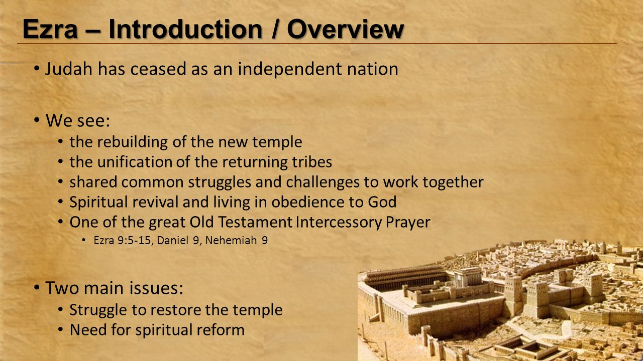

*Nehemiah and Ezra lived approximately at the same time, and were both faithful men. Each had a heart for the Lord, and each was raised up of the Lord for a specific purpose. However, it is evident that their characters were very different. Nehemiah arrived in Jerusalem some years after Ezra had been there, and some have suggested that there had been failure on Ezra’s part, in that he concentrated on teaching the people and dealing with their sins, while the walls of Jerusalem lay in ruins. He had surely seen all the rubbish and the desolation of the wall, and some have questioned why he did not address the matter, as well as being occupied with the people and the temple.*