**An Introduction to the BIBLE**

**Lesson 2: Genesis 12-50**

*Genesis is divided into two main parts. Chapters 1-11 detail the story of God and his relationship to the whole word, while chapters 12-50 focus on the story of God's relationship with Abraham and his family.*

Remember the main questions we’d always like the Bible to answer: Who, What, Why, When, How, Where. In the back of your SPARK Bibles, the orange pages have maps. Find M2 and M3. The bottom left corner of the map has “miles and kilometers” so you can see how far they walked. On the long chart handout in the section “The Promise” one side of the chart has an “estimated” timeline for when these things may have happened and what else was happening in the world at the same general time. See if you can answer “WHO” and “WHAT” and “WHY” after reading Genesis 12:1-9 and Genesis 15:1-6.

Here is a list of genealogy of some of the key figures in Genesis and Exodus:

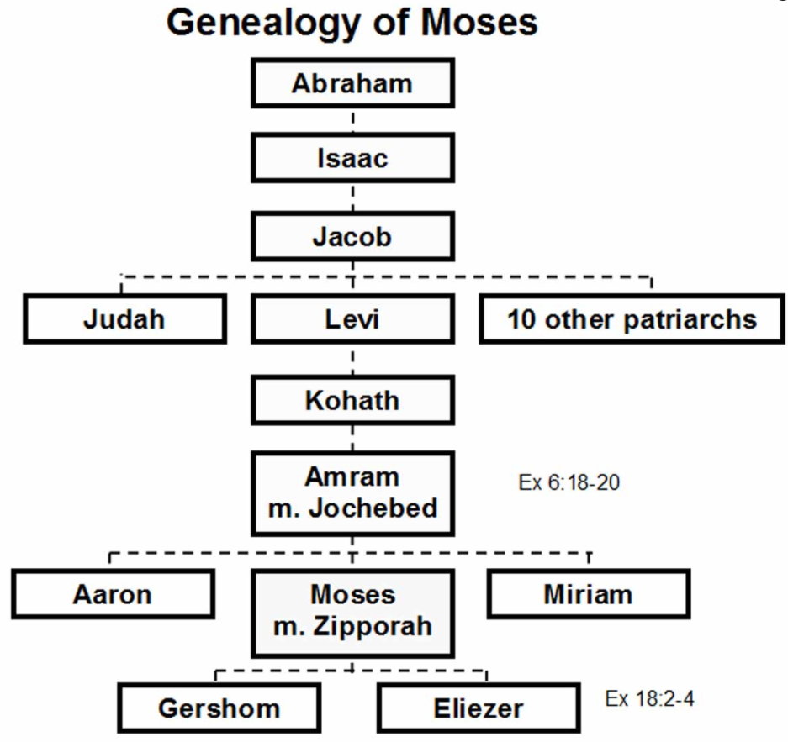

To the left of Isaac’s name, write “son of Sarah”. To the right of Isaac’s name write “Ishmael, son of Abraham and Hagar.” To the right of Jacob, write “older twin was named ESAU”. To the right of “10 other Patriarchs” write “JOSEPH”.

At the start of both Matthew and Luke’s Gospels we find a chart showing the genealogy of Jesus which goes back to these people in the Old Testament.

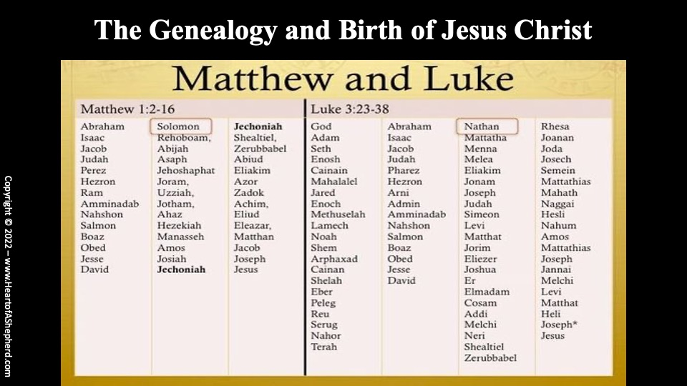

How many questions on our list above are we NOT able to answer about Abraham and Sarah? Let’s move on to Isaac—

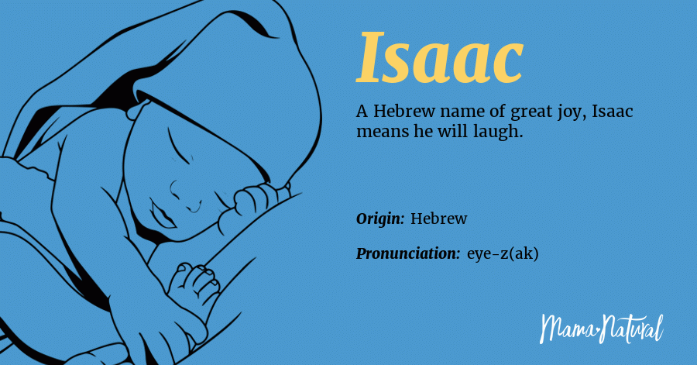

*The Bible uses the term “child of promise” to refer specifically to Isaac, the son God promised to deliver to Abraham and Sarah. Abraham had 8 children (Gen. 25:2, 9) but only Isaac was the child of promise (Gen. 21:12).*

After Isaac is born and is a young man, God gives a real strange command to Abraham to see if there is both trust AND obedience in Abraham. Genesis 22:1-19

*By asking him to sacrifice Isaac, God was testing Abraham to see if he trusted Him. And he did: Abraham's faith in God was so great that he was willing to give Him his only son, trusting that God could bring him back from the dead.*

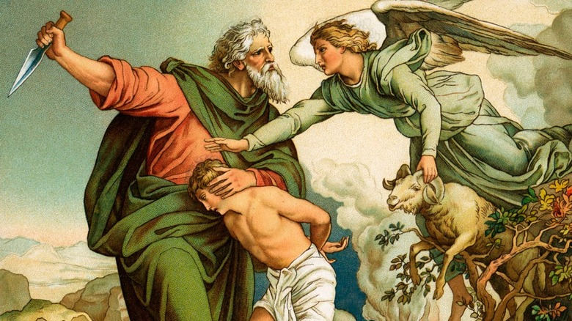

Isaac grows up and marries Rebekah. They have twin sons, Esau (older) and Jacob. The first-born son of the family has the right then to inherit from his father the same spiritual blessing from God that had been given first to Abraham and secondly to Isaac. (So this spiritual blessing should have gone to Esau). The second part was a privileged name and honor (called a “birthright”) which should also have gone to Esau as he was the firstborn.

Unfortunately, in this family there was some friction. Esau was his father isaac’s favorite and Jacob was his mother Rebekah’s favorite. Rebekah even decided to help Jacob trick his father so Isaac would give HIM the blessing and not Esau! Their plan works. Esau has earlier given Jacob his birthright for some food that Jacob had bee cooking as Esau was starving and didn’t value his future gift.

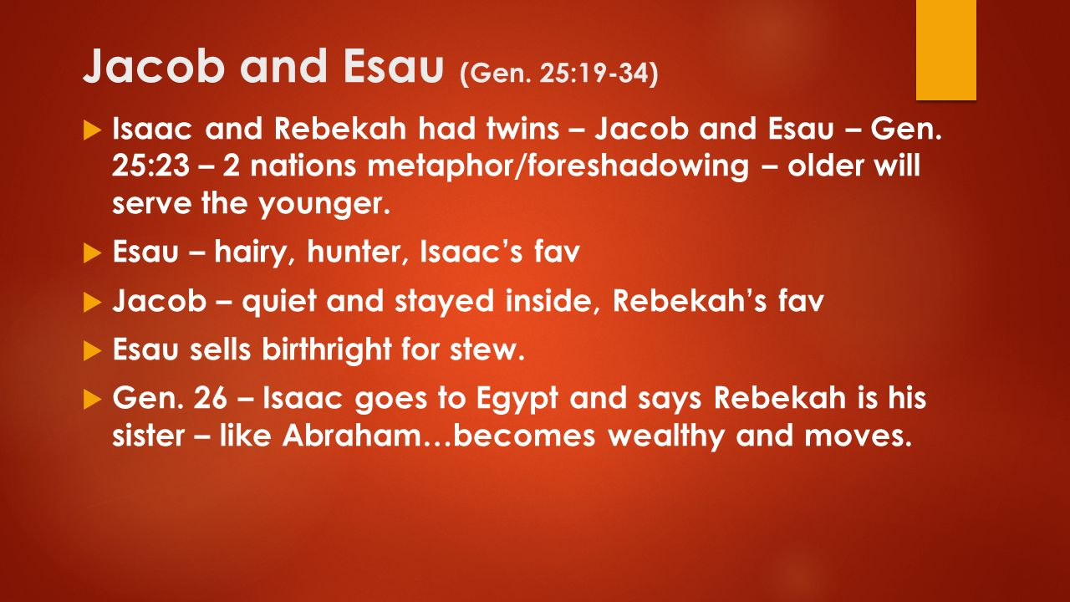

Genesis 27:41- Genesis 28:5 tell how Rebekah figured out how to get her husband Isaac to let Jacob leave in order to keep him safe since Esau had vowed to kill him after Isaac (who is very old, frail, and almost blind) passes away.

In Genesis 28:10-the end of the chapter Jacob spends his first night away from his family and has a dream that persuades him to make his own bargain with God!

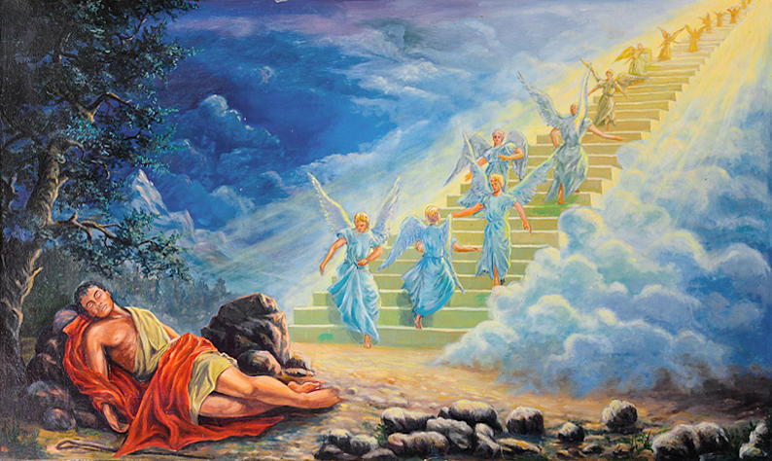

Jacob gets to his destination and meets a beautiful woman named Rachel whom he falls in love with. Rachel also has an older sister named “Leah” who is also unmarried. Their father is named “Laban”. He offers Jacob a bargain—if Jacob works for him for 7 years he can marry Leah. Jacob agrees but after 7 years he is tricked into marrying Leah instead so he has to work another 7 years in order to get permission to marry Rachel also. Both Rachel and Leah have maids and in that culture at that time, wives could have their maids spend a night with their husbands and the children of that union would be part of the wives’ family as well!