**An Introduction to the Bible**

**Lesson 4: Moses and the Exodus from Egypt**

Joseph and his extended family have all emigrated to Egypt due to the famine. Things go well for a while, but then Joseph eventually dies, there is a new Pharaoh who is concerned about all these Israelite “foreigners” who keep on having babies and using up valuable resources. Gradually the Israelites lost their privileges as “honored guests” and become slaves, helping build the pyramids and cities.

*What time period did Joseph live in Egypt?*

*corresponds with the Egyptian chronology, which counts four hundred years between one of the Hyksos kings and Rameses II., whom Dr. Brugsch does not doubt was the foster-father of Moses. Joseph, therefore, lived between 1800 and 17000 B. C. These Hyksos were Hittites, and belonged to the Turan- ian family.*

*What are the two main dates given for the Exodus?*

*Most people called these two approximated results as early date and late date of exodus. Scholars suggest that the early date of exodus is around 1446 BC (15th century), while the late date is around 1290 BC (13th century).*

Page 59 in your Bible has a summary of Exodus. Take a moment to review it.

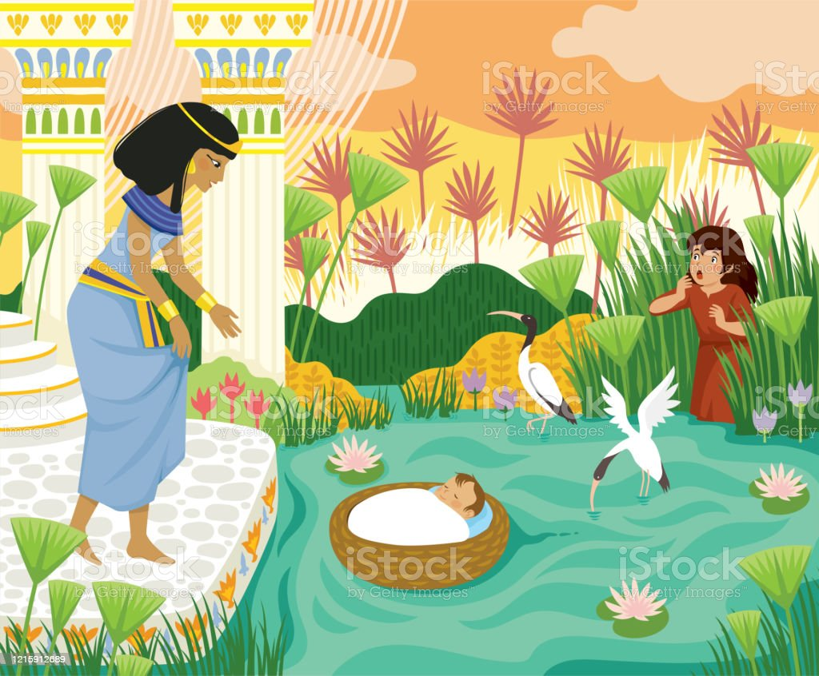

In Exodus 1 and 2 we learn that Pharaoh is frightened of the growing numbers of Hebrews so wants all male babies thrown into the Nile river but the female babies can live. Moses is born (bottom of page 61 tells what his name means) and kept safe for 3 months but eventually his mother can’t hide him any longer so she puts him in a basket, sets him on the Nile river, and has sister follow him on shore where she sees Pharaoh’s daughter find the basket and immediately bonds with the baby boy and raises him as part of her family! He is raised as an Egyptian prince but is sympathetic to the Hebrew slaves, so when an Egyptian overseer whips one of the slaves, Moses kills the Egyptian, then realizes what he’s done and flees from Egypt, thinking he’ll never come back. He stays away 40 years. Then one day as he’s watching his flock of sheep God speaks to him a burning bush and commands him to go back to Egypt and lead the Hebrews out of slavery! Exodus 3:9-15 shows how God is going to help him prove to the Hebrews that God spoke to him.

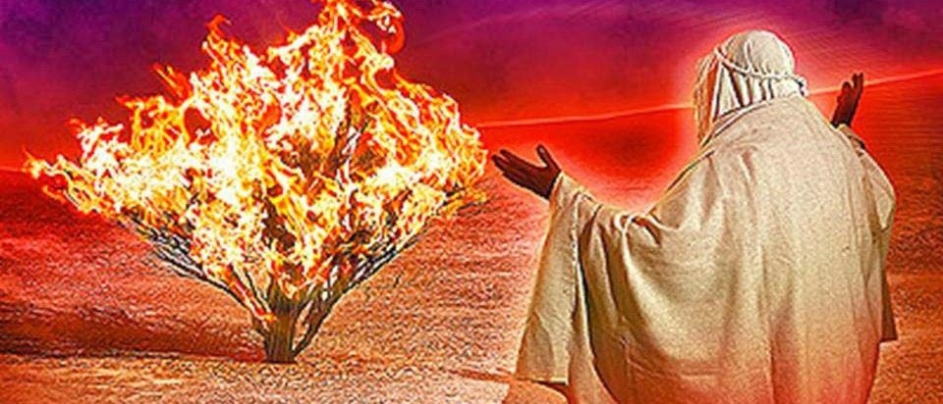

Exodus chapters 7-10 talk about the 9 plagues that God sent over Egypt as a sign that God was more powerful than the Egyptian “gods” and that Pharaoh should give in and let God’s people go. The 10th plague is the death of all the firstborn in Egypt but God has Moses tell the people to have each family sacrifice a lamb and smear the lambs’ blood on the doors of their houses—this is so when the “angel of death” is sent by God to Egypt that the angel will see the blood and will not come down to slay anyone inside—the angel will PASS OVER those homes. And the devastation will be so severe Pharaoh may tell the Hebrews to “GET OUT!” immediately so they should have a quick meal ready to eat and be ready to go.

This “Passover Meal” is a way that Jewish families celebrate every year to remember how God led them out of slavery into Egypt. Jesus and his disciples were also celebrating the Passover meal on the last night of his life when Jesus CHANGES the ritual by saying, “This is my body” and “This is my blood” to transform the meal (Christians believe) into Holy Communion!

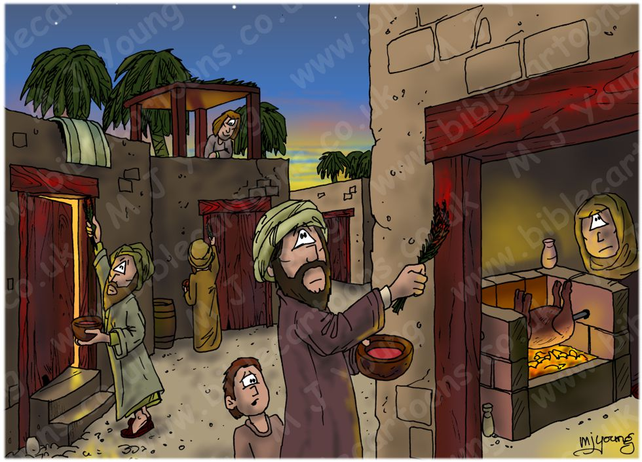

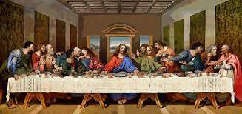

Exodus 14 has the Hebrew people trying to leave Egypt while Pharaoh and his army in their chariots are now pursuing them! They get to a body of water and fear drowning or being slaughtered but Moses prays to God and a strong wind blows the water back so they can pass through. When they get to the other side and the Egyptians try to follow the winds stop blowing and the water returns to its normal depth and the Egyptians drown!

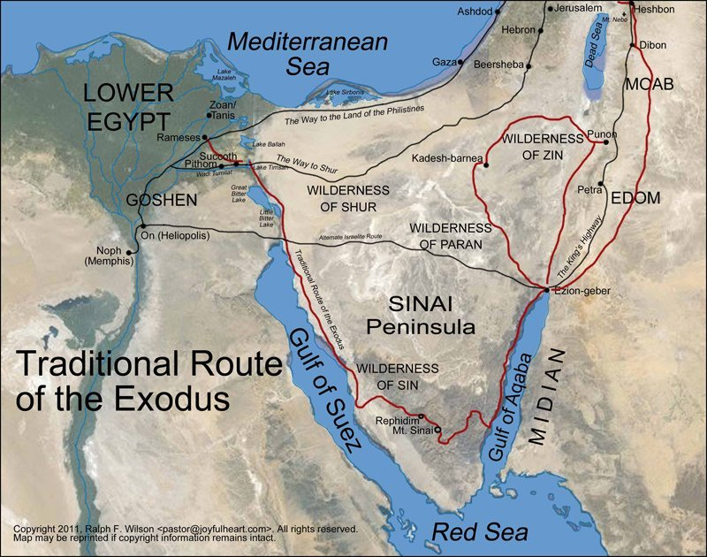

We have always spoken of the Exodus as “Crossing the RED Sea”. This could be a mistranslation of the Hebrew where it actually reads “Sea of REEDS”. Another factor is that there are places just below the Mediterranean Sea where the water is more swampy and is occasionally passable—plus this is near where the Hebrews were living before they were allowed to leave. Why would they travel all the way south to the huge Red Sea to go across to safety when they could go the shorter way up north? Do a google search and you’ll find all kinds of info about this.

Exodus 19 and 20 has Moses leading the Israelites to Mt Sinai where he goes up to receive the Ten Commandments from God. You can also find a list of the Ten Commandments in Deuteronomy 5. While Moses is up on the mountain there is a rebellion in the Hebrew camp with some wanting to go back to Egypt and even using all the gold jewelry from people to be melted down and made into an image of a golden calf that they can worship! (chapter 32) Moses is NOT happy, throws down the tablets with the commandments and has to go back up and get another set! (chapter 34).

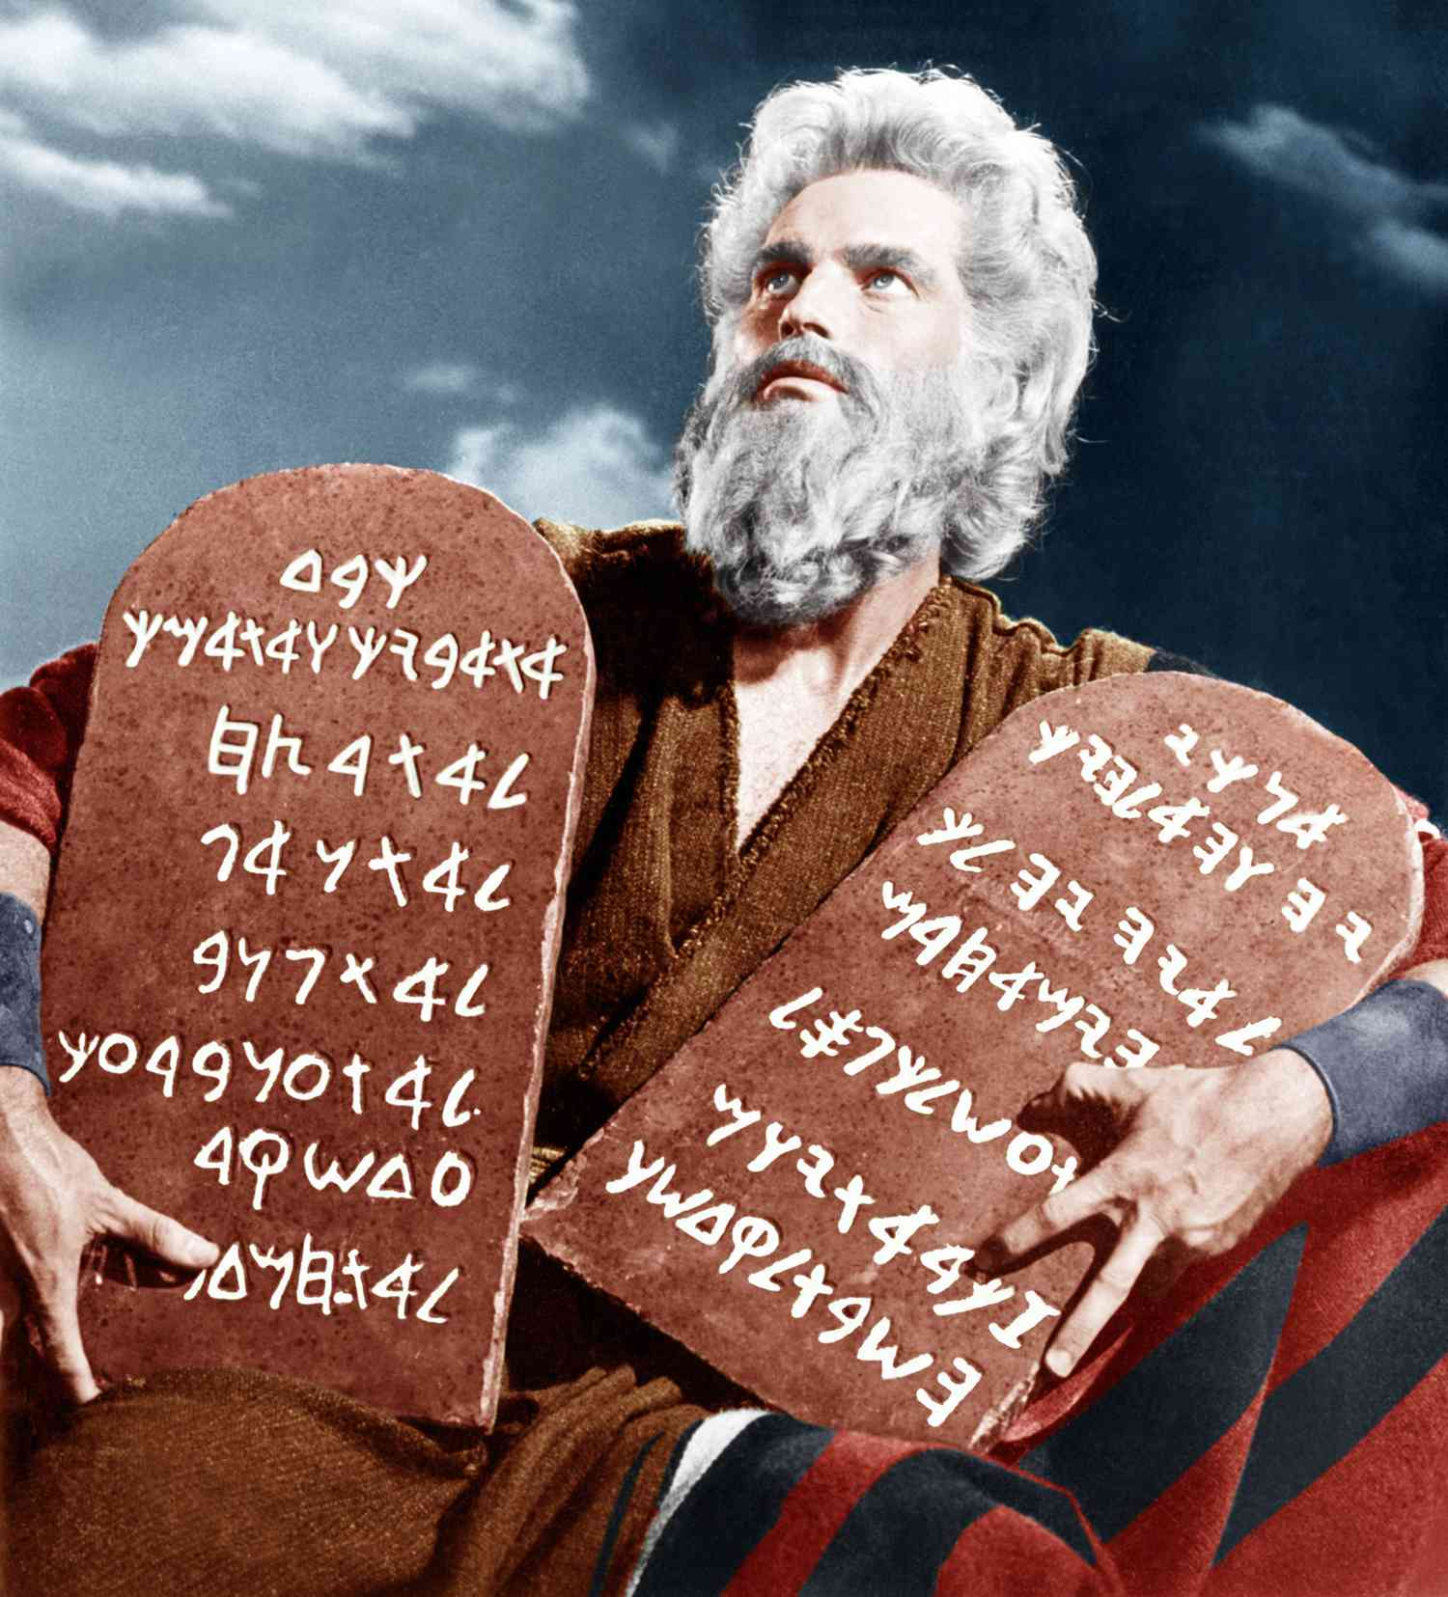

Moses leads the people for a long time and is able to look over the River Jordan and SEE the promised land but dies and nobody knows where he is buried. Now Joshua takes over to lead the conquest of the promised land for the Hebrews.