Traditional Service November 28, 2021
Zion Lutheran Church, Aberdeen, SD
First Sunday of Advent
zionlutheranaberdeen.org
Mark Galbraith, Interim Pastor

INTRODUCTION TO THE DAY
Advent is about the “coming days.” God’s people have always lived in great expectation, but that expectation finds specific, repeated enunciation in the texts appointed for these four weeks. The ancients anticipated a “righteous Branch to spring up for David.” The Thessalonians awaited “the coming of our Lord Jesus with all the saints.” Jesus’ contemporaries hoped for the time “to stand before the Son of Man.” With them we eagerly await the coming days: another Christmas celebration, a second coming, and the advent of Christ in word and supper.

WELCOME AND ANNOUNCEMENTS

LIGHTING OF THE ADVENT WREATH Beusch Family

HYMN Light the Candle to Watch for the Messiah ELW #240
Vs. 1
1 Light one candle to watch for Messiah:
let the light banish darkness.
He shall bring salvation to Israel,
God fulfills the promise.

INVOCATION
Blessed by the holy Trinity, ☩ one God,
who alone does wonders, who lifts up the lowly,
who fills the hungry with good things.
Amen.

CONFESSION AND FORGIVENESS
Let us confess our sin, trusting in the tender mercy of our God.

Silence for reflection and personal confession.

God for whom we wait,
in the presence of one another, we confess our sin before you.
We fail in believing that your good news is for us.
We falter in our call to tend your creation.
We find our sense of self in material wealth.
We fear those different from ourselves.
We forget that we are your children
and turn away from your love.
Forgive us, Blessed One,
and assure us again of your saving grace.
Amen.

God, in Christ Jesus, has looked with favor upon you!
Through the power of the Holy Spirit,
☩ your sins are forgiven.
You are children of the Most High,
inheritors of the eternal promise,
and recipients of divine mercy.
God strengthens you anew to follow the way of peace.
Amen.
GREETING
The grace of our Lord Jesus Christ, the love of God, and the communion of the Holy Spirit be with you all. And also with you.

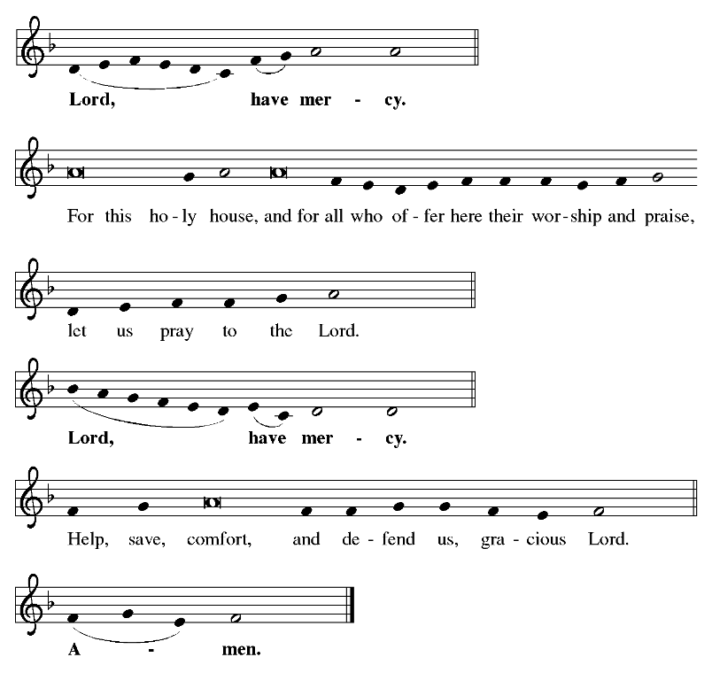
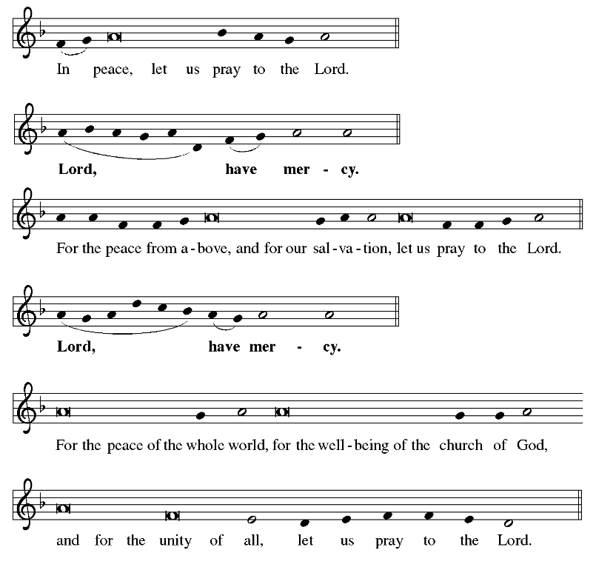
KYRIE (ELW, p. 156)

Prayer of the Day
Let us pray together:
Stir up your power, Lord Christ, and come. By your merciful protection alert us to the threatening dangers of our sins, and redeem us for your life of justice, for you live and reign with the Father and the Holy Spirit, one God, now and forever.
Amen.

KIDS’ TIME Pastor Mark

FIRST READING Jeremiah 33:14-16
¹⁴The days are surely coming, says the LORD, when I will fulfill the promise I made to the house of Israel and the house of Judah. ¹⁵In those days and at that time I will cause a righteous Branch to spring up for David; and he shall execute justice and righteousness in the land. ¹⁶In those days Judah will be saved and Jerusalem will live in safety. And this is the name by which it will be called: "The LORD is our righteousness."

Word of God. Word of life. Thanks be to God.

PSALM Psalm 25:1-10 (read responsively)
¹To you, O LORD, I lift up my soul.
²O my God, in you I trust;
do not let me be put to shame;
do not let my enemies exult over me.
³Do not let those who wait for you be put to shame;
let them be ashamed who are wantonly treacherous.
⁴Make me to know your ways, O LORD;
teach me your paths.
⁵Lead me in your truth, and teach me,
for you are the God of my salvation;
for you I wait all day long.
⁶Be mindful of your mercy, O LORD, and of your steadfast love,
for they have been from of old.
⁷Do not remember the sins of my youth or my transgressions;
according to your steadfast love remember me,
for your goodness' sake, O LORD!
⁸Good and upright is the LORD;
therefore he instructs sinners in the way.
⁹He leads the humble in what is right,
and teaches the humble his way.
¹⁰All the paths of the LORD are steadfast love and faithfulness,
for those who keep his covenant and his decrees.

SECOND READING 1 Thessalonians 3:9-13
⁹How can we thank God enough for you in return for all the joy that we feel before our God because of you? ¹⁰Night and day we pray most earnestly that we may see you face to face and restore whatever is lacking in your faith.
¹¹Now may our God and Father himself and our Lord Jesus direct our way to you. ¹²And may the Lord make you increase and abound in love for one another and for all, just as we abound in love for you. ¹³And may he so strengthen your hearts in holiness that you may be blameless before our God and Father at the coming of our Lord Jesus with all his saints.

Word of God. Word of life. Thanks be to God.

GOSPEL ACCLAMATION O Come, O Come Emmanuel ELW #257
Vs. 1 & 2
1 O come, O come, Emmanuel,
and ransom captive Israel,
that mourns in lonely exile here
until the Son of God appear.

Refrain
Rejoice! Rejoice! Emmanuel
shall come to you, O Israel.

2 O come, O Wisdom from on high,
embracing all things far and nigh:
in strength and beauty come and stay;
teach us your will and guide our way. Refrain

The holy gospel according to Luke.
Glory to you, O Lord.

GOSPEL Luke 21:25-36
²⁵There will be signs in the sun, the moon, and the stars, and on the earth distress among nations confused by the roaring of the sea and the waves. ²⁶People will faint from fear and foreboding of what is coming upon the world, for the powers of the heavens will be shaken. ²⁷Then they will see 'the Son of Man coming in a cloud' with power and great glory. ²⁸Now when these things begin to take place, stand up and raise your heads, because your redemption is drawing near."
²⁹Then he told them a parable: "Look at the fig tree and all the trees; ³⁰as soon as they sprout leaves you can see for yourselves and know that summer is already near. ³¹So also, when you see these things taking place, you know that the kingdom of God is near. ³²Truly I tell you, this generation will not pass away until all things have taken place. ³³Heaven and earth will pass away, but my words will not pass away.
³⁴Be on guard so that your hearts are not weighed down with dissipation and drunkenness and the worries of this life, and that day does not catch you unexpectedly, ³⁵like a trap. For it will come upon all who live on the face of the whole earth. ³⁶Be alert at all times, praying that you may have the strength to escape all these things that will take place, and to stand before the Son of Man."

The gospel of the Lord.
Praise to you, O Christ.

Sermon Pastor Mark Galbraith

Hymn of the Day Joy to the World ELW #267
1 Joy to the world, the Lord is come!
Let earth receive her king;
let ev'ry heart prepare him room
and heav'n and nature sing,
and heav'n and nature sing,
and heav'n, and heav'n and nature sing.

2 Joy to the earth, the Savior reigns!
Let all their songs employ,
while fields and floods, rocks, hills, and plains
repeat the sounding joy,
repeat the sounding joy,
repeat, repeat the sounding joy.

3 No more let sin and sorrow grow
nor thorns infest the ground;
he comes to make his blessings flow
far as the curse is found,
far as the curse is found,
far as, far as the curse is found.

4 He rules the world with truth and grace
and makes the nations prove
the glories of his righteousness
and wonders of his love,
and wonders of his love,
and wonders, wonders of his love.

APOSTLES’ CREED
God has made us God’s people through our Baptism into Jesus the Messiah. Living together in trust and hope, we confess our faith.

I believe in God, the Father almighty,
creator of heaven and earth.
I believe in Jesus Christ, God’s only Son, our Lord,
who was conceived by the Holy Spirit,
born of the virgin Mary,
suffered under Pontius Pilate,
was crucified, died, and was buried;
he descended to the dead.
On the third day he rose again;
he ascended into heaven,
he is seated at the right hand of the Father,
and he will come to judge the living and the dead.
I believe in the Holy Spirit,
the holy catholic church,
the communion of saints,
the forgiveness of sins,
the resurrection of the body,
and the life everlasting. Amen.

PRAYERS OF THE CHURCH
In this season of watching and waiting, let us pray for all people and places that yearn for God’s presence.
Prayer response: Hear us, O God. Your mercy is great.

God of new life, you come among us in the places we least expect. Receive these prayers and those of our hearts, in the name of Jesus. Amen.

SHARING OF THE PEACE
The peace of the Lord be with you always.
And also with you.


OFFERING
Offering will not be taken during worship; a basket is available in the back of the sanctuary to drop off today’s offering. We encourage you to consider giving a gift online at zionlutheranaberdeen.org/giving or by mail as you are able. If you would like, use the QR code scanner on your smart phone to give online.

OFFERING HYMN Hark, the Glad Sound! ELW #239
1 Hark, the glad sound! The Savior comes,
the Savior promised long;
let ev'ry heart prepare a throne
and ev'ry voice a song.

2 He comes the pris'ners to release,
in Satan's bondage held.
The gates of brass before him burst,
the iron fetters yield.

3 He comes the broken heart to bind,
the bleeding soul to cure,
and with the treasures of his grace
to enrich the humble poor.

4 Our glad hosannas, Prince of peace,
your welcome shall proclaim,
and heav'n's eternal arches ring
with your beloved name.

OFFERING PRAYER
Let us pray together:
God of our waiting and watching, we offer the gifts of our hearts and our lives to the service of all your people. Prepare the way before us as we meet you in this time, through Christ Jesus, our pathway and our peace. Amen.

LORD’S PRAYER
Let us pray in confidence the words our Savior gave us:

Our Father, who art in heaven,
hallowed be thy name, thy kingdom come,
thy will be done, on earth as it is in heaven.
Give us this day our daily bread;
and forgive us our trespasses,
as we forgive those who trespass against us;
and lead us not into temptation, but deliver us from evil.
For thine is the kingdom, and the power, and the glory,
forever and ever. Amen.

BENEDICTION
The God of hope fill us with all joy and peace in believing,
so that we may abound in hope
by the power of the Holy Spirit,
through ☩ Christ Jesus for whom we wait.
Amen.

SENDING HYMN Awake! Awake, and Greet the New Morn ELW #242
1 Awake! Awake, and greet the new morn,
for angels herald its dawning.
Sing out your joy, for soon he is born,
behold! the Child of our longing.
Come as a baby weak and poor,
to bring all hearts together,
he opens wide the heav'nly door
and lives now inside us forever.

2 To us, to all in sorrow and fear,
Emmanuel comes a-singing,
his humble song is quiet and near,
yet fills the earth with its ringing;
music to heal the broken soul
and hymns of lovingkindness,
the thunder of his anthems roll
to shatter all hatred and blindness.

3 In darkest night his coming shall be,
when all the world is despairing,
as morning light so quiet and free,
so warm and gentle and caring.
Then shall the mute break forth in song,
the lame shall leap in wonder,
the weak be raised above the strong,
and weapons be broken asunder.

4 Rejoice, rejoice, take heart in the night,
though dark the winter and cheerless,
the rising sun shall crown you with light,
be strong and loving and fearless.
Love be our song and love our prayer
and love our endless story;
may God fill ev'ry day we share
and bring us at last into glory.

SENDING WORDS
Go in peace. Christ is near. Thanks be to God.

POSTLUDE

From Sundays and Seasons.com. Copyright 2021 Augsburg Fortress. All rights reserved.
Reprinted by permission under Augsburg Fortress Liturgies Annual License #26593.

New Revised Standard Version Bible, copyright 1989, Division of Christian Education of the National Council of the Churches of Christ in the United States of America.

